Tournament Update February 27, 2021

Hi everyone. I’m sure everyone is into the swing of Term One and teams are gearing up for tournament.

There have been a number of great questions come through from different schools that we think need to be shared with everyone. So in no particular order...

Team make up is 20 students. Teams may choose to have a variation on this e.g. 9 boys and 11 girls.

The Reefton Development Team boys are a team of 10. The Reefton Development Team Girls will be made up of a wider squad. For round robin games where the Girls Development Team are playing, the opposing team will progress through the pool play regardless of the result.

We would like team confirmation to be sent through to Wayne. Please include a playing number.

The skit competition. The presentation has to be suitable for a mixed audience. Content and language is to be appropriate for public performance.

It is not too late to order tournament tops. Please make contact with Katie at office@ras.school.nz if you want to discuss this.

There is an error in the Food Challenge. There is no requirement to prepare a menu. This is an error in the booklet.

The badminton court is 13.4m long and 6.1m wide. For singles the court is marked 5.18m wide. The lines marking out the court are easily distinguishable and coloured white or yellow. The lines are 40mm wide.

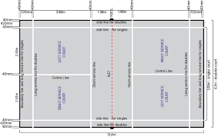
The two venues are the hall and the gym. Cheers, Wayne

